Project Planning Phase

Milestone and Activity list

Date

Team ID

Project Name

24 October 2022

PNT2022TMID44897

AI-based localization and classification of Skin Disease with Erythema

Milestone | Activity | Description | Date
Create the | Create the dataset from | Create the dataset to train the | 29 Oct 2022
Dataset | Scratch | YOLO Model
 | YOLO Object detector | Upload the dataset to detect and | 29 Oct 2022
 |  | Train the YOLO Object detector.
 | Collect the Images | Collect at least 50 images of each | 29 Oct 2022
 |  | type of Skin disease using Google.
Training YOLO | Train the model using | To Predict the output model is | 05 Nov 2022
 | YOLO weights | Trained with YOLO Weight.
 |  | Download the pre-trained YOLOv3 | 05 Nov 2022
 | Download And Convert Pre- | Download the pre-trained YOLOv3
 | Download And Convert Pre- | weights and convert them to the Keras
 | Trained Weights | Format.
 |  | Run the training script | 05 Nov 2022
 | Train YOLOv3 Detector | Run the training script
 |  | from within the
 |  | [`yolo_structure
/2_Training`]
(/2_Training
 |  | /) directory:
 | Creating and | Register & Login to IBM Cloud | 05 Nov 2022
 | Creating and | Create Service Instance
Cloudant DB | using Cloudant | Creating Service Credentials
 | Service. | Launch Cloudant DB
 | Service. | Create Database
 |  | Register To IBM Cloud | 05 Nov 2022
 | Register & Login To IBM
 | Cloud | Sign in with your credentials

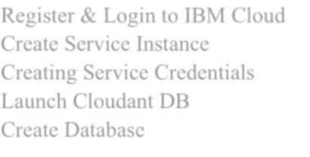

 |  | Select region as Dallas & Type an | 05 Nov 2022
 | Create Service Instance | instance name then click on create
 |  | Service.
 |  | To create the connection | 05 Nov 2022
 | Creating Service Credentials | information that your application
 |  | needs to connect to the instance,
 |  | Click New credential.
 |  | .

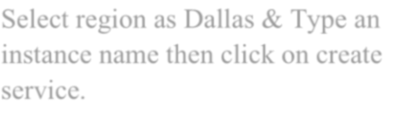
 |  | Cloudant DB launches as a New | 05 Nov 2022
 | Launch Cloudant DB | User you will find empty database
Dashboard | Dashboard Creation | Create Dashboard for Capturing | 12 Nov 2022
 |  | images or video and to upload and
 |  | get the results.
Report | Report Creation | Create Report to visualize detailed | 19 Nov 2022
 |  | report of localization and
 |  | classification of Skin disease
Story | Story Creation | Create story to make on the | 19 Nov 2022
 |  | detailed working Structure.

